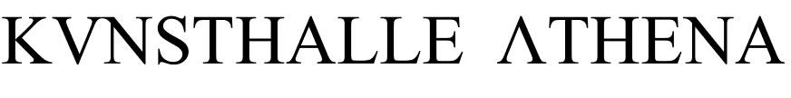

POLITICAL SPEECH # 9

Rosemary Lee
The Tyranny of the Free

Media artist and theorist Rosemary Lee will deliver a presentation covering her work as Burning Athens artist / scholar in residency, confronting the interaction between art, politics, and economics. The Tyranny of the Free represents an ongoing inquiry into these connections, particularly analysing the misappropriation of the word free and its double use or shift from the notion of freedom to that of the contemporary meaning of the free of charge. She will also be presenting a sound work, which she has been developing during the residency.

Rosemary Lee is a media artist and theorist whose nomadic practice roams between the disciplines of philosophy, art, science, economics, politics, poetry, and music. Rosemary's artwork has been exhibited in the United States, France, Spain, and Germany, while being developed in several long-term international collaborations. She has recently been short-listed for the Franc Villa Prize, and is currently working toward an exhibition at the experimental media-art laboratory Science Friction, in Copenhagen. (www.rosemary-lee.com)

Burning Athens is a platform of events and residencies for contemporary visual artists and writers based in Athens. The program is directed by Georgios Papadopoulos and Pati Vardhami.

THIS MUST BE THE PLACE

Solo shows:
Katerina Kana, Thanos Kyriakides (BLIND ADAM) and Petros Touloudis
The exhibition features also works by: Sotiris Bakagiannis, Angelo Plessas, Socratis Socratous, Maria Tzanakou

Duration: May 9 - August 1, 2013
Visiting hours: Wednesday - Thursday, 18:30 - 22:00

Bar with Greek raki
Free entrance

Supported by Media Partner
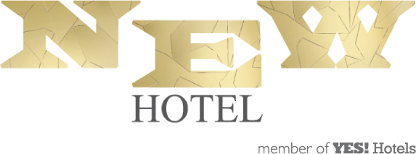

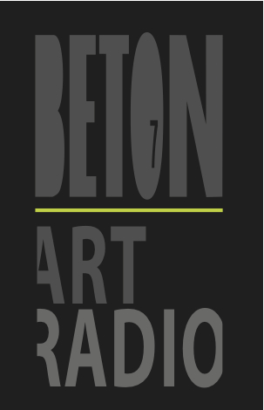

Kunsthalle Athena, 28, Kerameikou Street, Kerameikos - Metaxourgeio, Athens, Greece
www.kunsthalleathena.org

